**MultiProcessing Assignments**

2]

a) Ans:

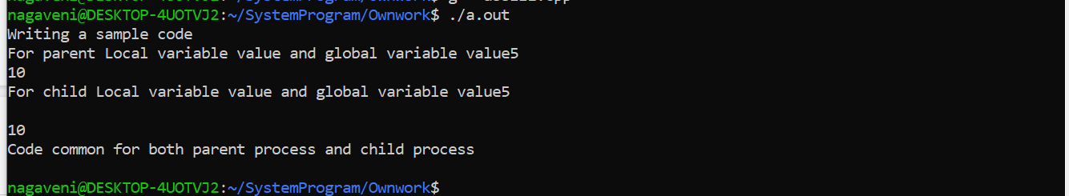

b) Ans: Yes ,  the value of local variable and global variable value will be same for both parent process and child process.

c) Ans: Yes, order of execution same everytime and there is no impact in the output.

d) Ans: Process executes last statement and then asks the operating system to delete it using the exit() system call. So, here we used exit() in child process , therefore the cout statement of child Process not displayed only parent process cout is displayed.